**ReactJS&Redux Practical Test**

Duration : 2 hrs

Mark : 50

**Specification :**

* Create a react component with two link
* AddPinDetails
* RetrivePinDetails
* The AddPinDetails will have the below screen which will accepts the data and stores in a store

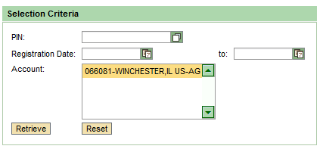

* 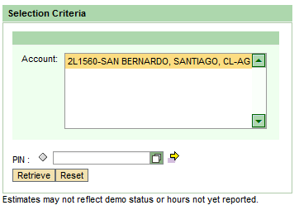The RetrivePinDetails will have below components when you enter the PIN and perform an action it will retrieve account details based on PIN entered.

**Technologies used :**

1. ReactJS to create a component
2. ReactRouter for Navigations
3. Redux to store the values.

**Evaluation Parameters:**

1. Creation of appropriate component with given attributes. – (20 Marks)
2. Coding standard/Comments. – (10 Marks) –
3. Implementation of derived components to demonstrate the completeness and correctness of the program. - (20 Marks)